Data Profiling Document
1. title_episode
Overview:
Total number of records: 9,324,110
Total number of Columns:4
Duplicate records :0

Column Names | Source Data Type | Target Data Type
tconst | V_String | V_String
parentTconst | V_String | V_String
seasonNumber | V_String | Integer
episodeNumber | V_String | Integer

Data Quality Assessment:

1. Duplicated Records
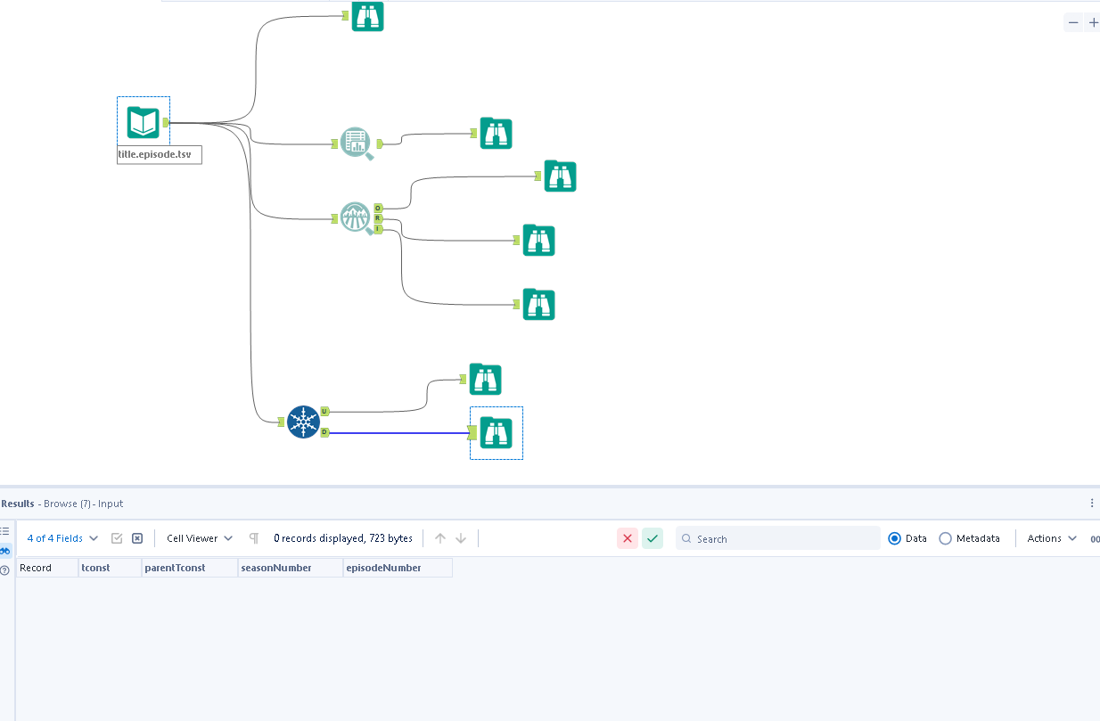
Detail : There are no duplicate record while selecting all the columns from the dataset.

2. Missing/Null values
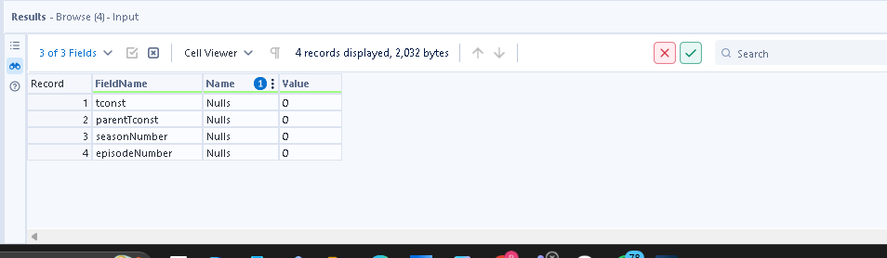
None of the fields have null /missing values

3. Leading and trailing whitespaces
There are no leading and trailing whitspaces in any of the columns in the entire dataset. Checked via basic profile toll

4. Contains ‘\N’ values :

Columns affected : seasonNumber, episodeNumber

Column Names | Replace ‘\N’ with | Reason
seasonNumber | -1 | To maintain numeric format
episodeNumber | -1 | To maintain numeric format

Summary Statistics:
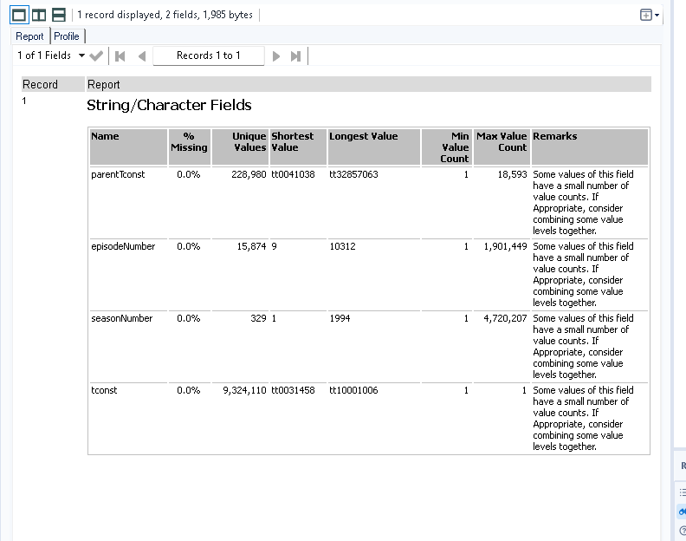

2. Title_ ratings
Overview:
Total number of records: 1605649
Total number of Columns:3
Duplicate records :0
Column Names | Source Data Type | Target Data Type
tconst | V_String | V_String
averageRating | V_String | double
numVotes | V_String | Integer

Data Quality Asssesment:
1. Duplicate records
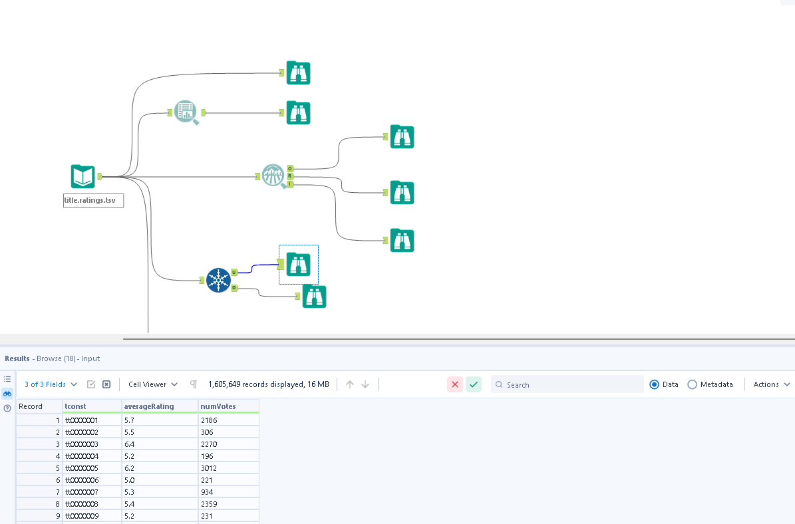
There are no duplicates in the entire dataset

2. Missing/Null values:
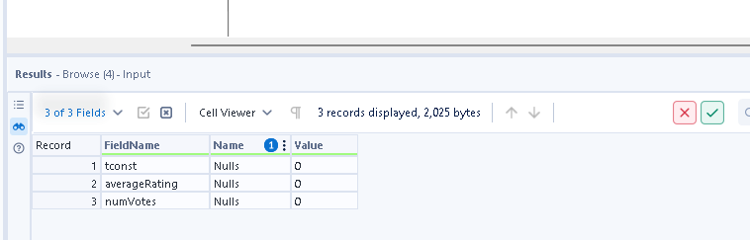
There are no nulls in the entire dataset

3. Leading and trailing whitespaces
There are no leading /trailing whitespaces in the entire dataset .Checked all the columns via basic data profile

Summary Statistics:
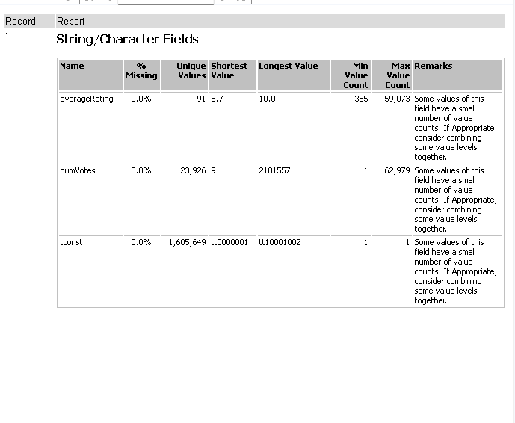

3. Title-Principles
Overview:
Total number of records: 96,132,477
Total number of Columns:4
Duplicate records : 0
Source to Target Datatype:
Column Names | Source Data Type | Target Data Type
tconst | V_String | V_String
ordering | V_String | Integer
nconst | V_String | V_String
job | V_String | V_String
characters | V_String | V_String
category | V_String | V_String

Data Quality Assessment

1. Missing/Null values:
Verified using basic data profiling tool
Affected Columns: tconst, ordering, nconst ,category, job, characters
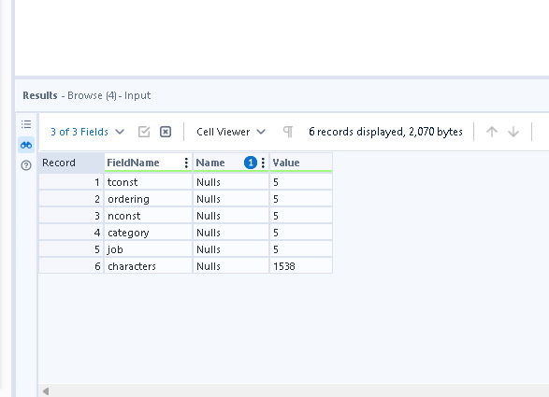
Plan of action:
Column Names | Replace with | Reason
tconst | ‘unknown’ | To maintain string format
ordering | ‘-1 ‘ | To main Integer format
nconst | ‘unknown’ | To maintain string format
job | ‘unknown’ | To maintain string format
characters | ‘unknown’ | To maintain string format
category | ‘unknown’ | To maintain string format

3.Leading and Trailing whitespaces:
Trailing and Both whitespaces:
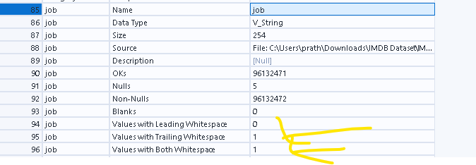
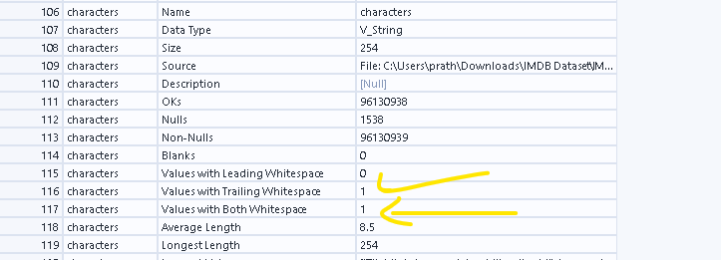
Affected columns: job and characters:
Plan of action :Remove the whitespaces in cleaning

4. Contains ‘N’ Values
Affected Columns
Column Names | Replace ‘\N’ with | Reason
job | ‘unknown’ | To maintain string format
characters | ‘unknown’ | To maintain string format

Summary Statistics:
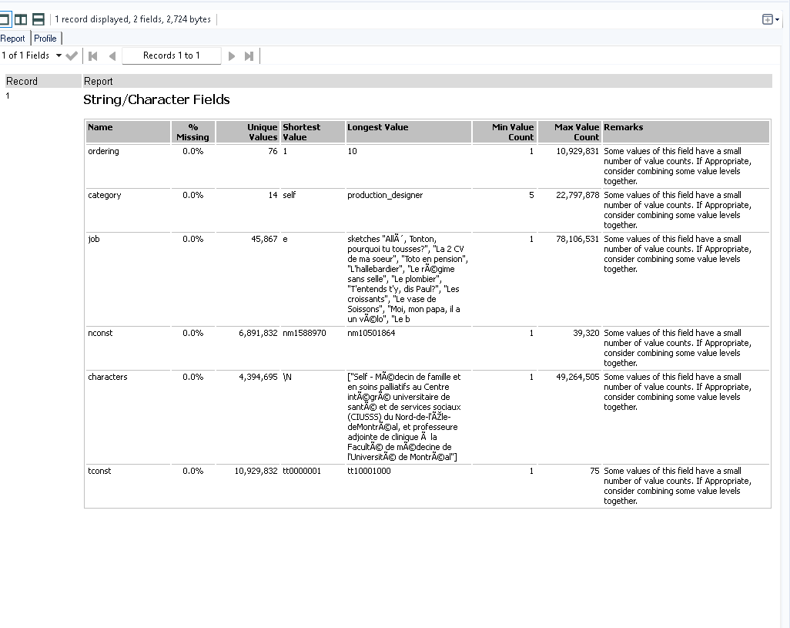

Title_crew
Overview:
Total number of records: 12,095,664
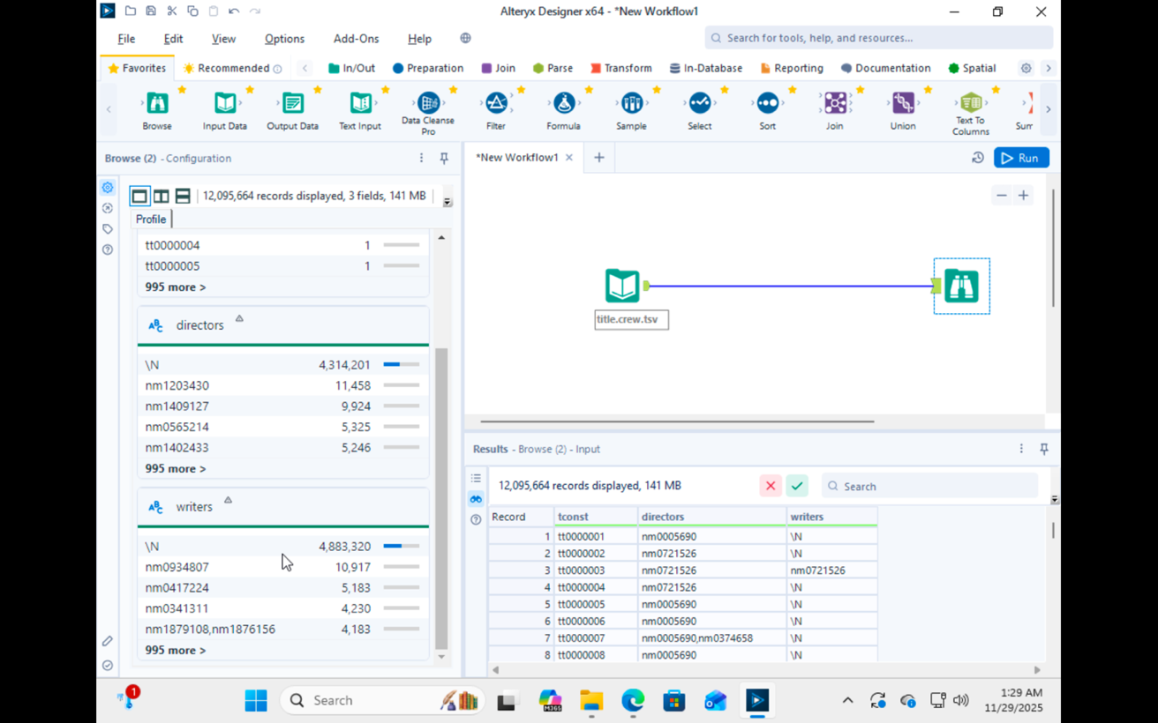
Total number of Columns:3
Duplicate records :0
Column Names | Source Data Type | Target Data Type
tconst | V_String | V_String
directors | V_String | V_String
writers | V_String | V_String

Data Quality Asssesment:
1. Missing /Null values:
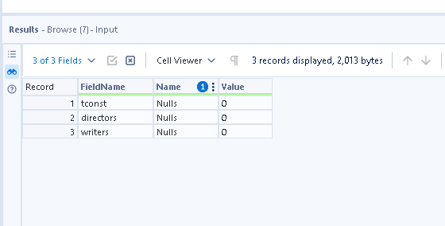
There are no nulls in the entire dataset

2. Leading/trailing whitespaces
There are no leading /trailing whitespaces in the dataset

3. Contains ’/N’ values:
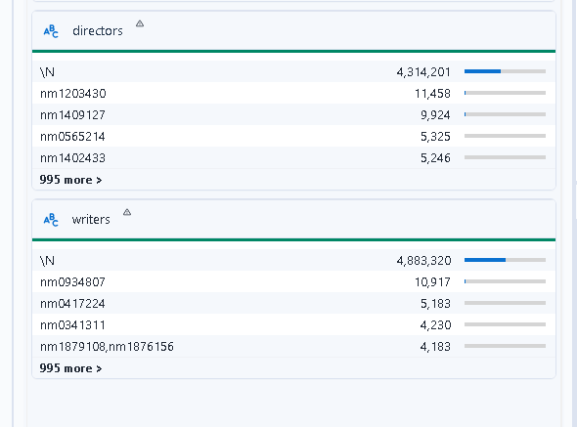
Action – need to replace ‘\N’ values in directors and writers with ‘unknown’ in cleaning

4. Comma-Separated Values
Need to flaten the table since multiple directors and writers are in same field in arrays which should be in different rows, so they would have to be exploded and a new field would have to be created called crew_role which would have the directors and writers
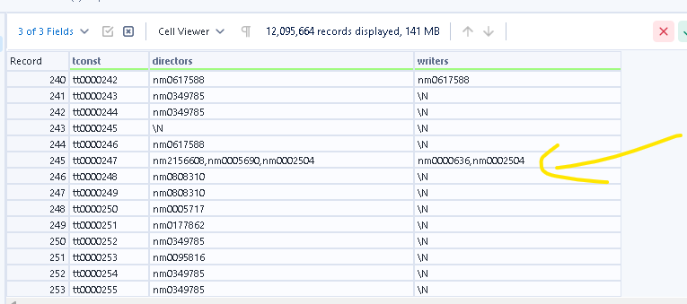

Title basics:

Overview:
Total number of records: 12,095,664
Total number of Columns:9
Duplicate records :0

Column Names | Source Data Type | Target Data Type
tconst | V_String | V_String
titleType | V_String | V_String
primaryTitle | V_String | V_String
originalTitle | V_String | V_String
isAdult | V_String | boolean
startYear | V_String | Integer
endYear | V_String | Integer
runtimeMinutes | V_String | integer
genres | V_String | V_String

Data Inconsitency:
1. Contains Nulls:

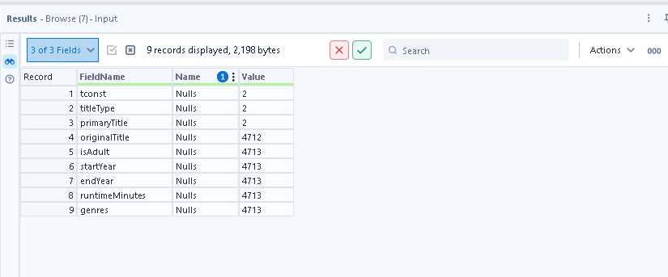
Action
Column Name | Replace with | Reason
tconst | Unknown | To maintain datatype format
titletype | Unknown | To maintain datatype format
primaryTitle | Unknown | To maintain datatype format
originalTitle | Unknown | To maintain datatype format
isAdult | -1 | To maintain datatype format
startYear | 0000 | To maintain YYYY format
endYear | 9999 | To maintain YYYY format
runtimeMinutes | -1 | To maintain datatype format
genres | Unknown | To maintain datatype format

2.. Contains ‘/N’ values:
Affected Columns: startYear ,endYear ,runtimeMinutes,genres

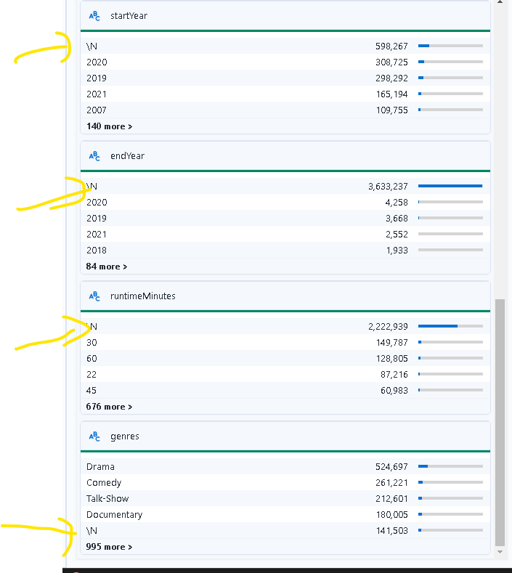

Action- Replace ‘\N’ with following:
Column Name | Replace with | Reason
startYear | 0000 | To maintain YYYY format
endYear | 9999 | To maintain YYYY format
runtimeMinutes | -1 | To maintain datatype format
genres | unknown | To maintain datatype format

2. Trailing whitespace:
Affected columns: primaryTitle , originalTitle
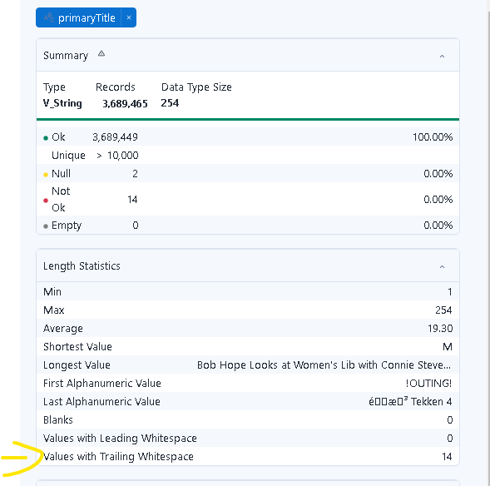
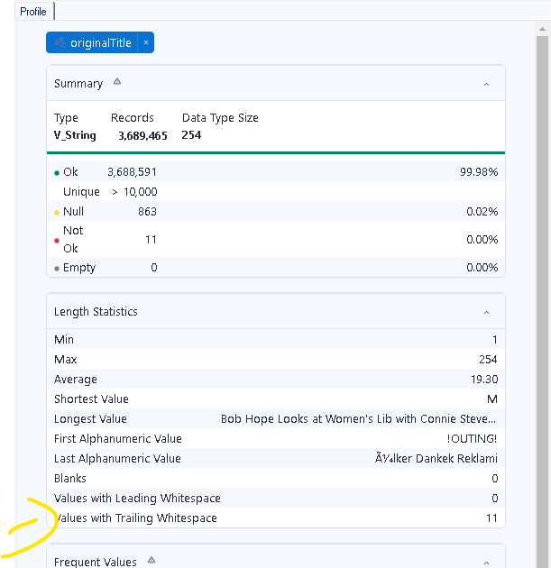

Action: Remove the trailing whitespaces using trim function in cleaning

3. Comma Seperated values
Genre field would have to be flattened since its having multiple values in a single field ie explore

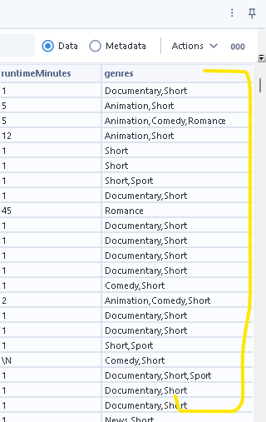

Additional verification
Checked if there are any records where end year is earlier than startYear
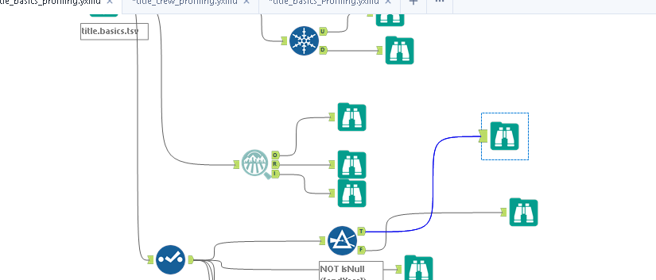
There are none in the dataset

Title_Region

Overall Records: 244
Total Number of columns: 2
Missing values overall :0
Duplicates :0

Column Name | Source Target Data type
REGION_NAME | String
REGION_CODE | String

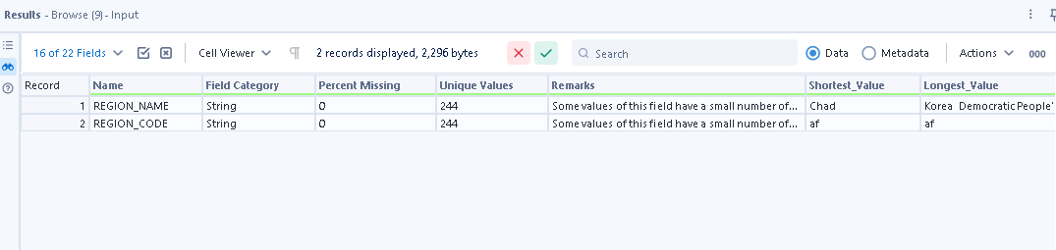
Conclusion- No issues identified in the dataset as its directly extracted from source

Title_Language_Codes

Overall Records: 183
Total Number of columns: 2
Missing values overall :0
Duplicates :0

Column Name | Source Target Data type
LANGUAGE_NAME | String
LANGUAGE_CODE | String

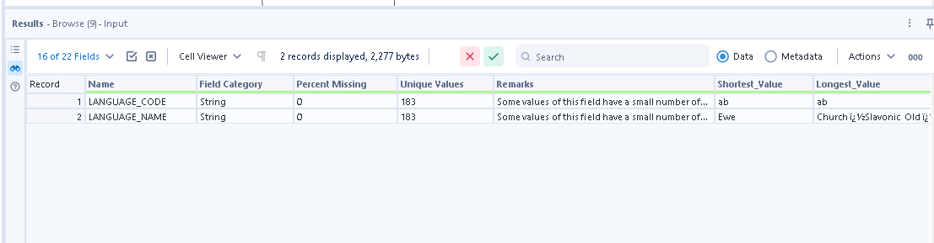

No issues identified in the dataset as its directly extracted from source

Dataset – name.basics

Total Records – 14,903,875
Total attributes – 6
Duplicates – 0

Column Name | Source Data type | Target Data Type
Nconst | V_String | V_String
primaryName | V_String | V_String
BirthYear | V_String | Integer
DeathYear | V_String | Integer
primaryProfession | V_String | V_String
knownForTitles | V_String | V_String

Key Observations –
1.There are no duplicates in the dataset.

2.Checking if the birthyear >= death year
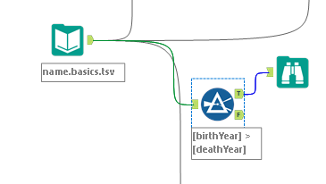

The \N values were handled by replacing with 0000

3. There are nulls in the birth Year which are represented by “\N” indicating that these details were not captured. We will replace all the “\N” by nulls first and then replace all these nulls with 0000 to indicate incorrect year format.
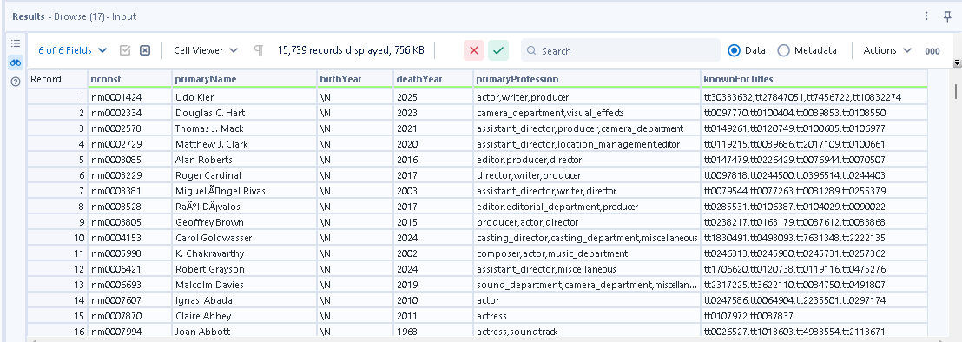

4. There are nulls in the death Year which are represented by “\N” indicating that these people are alive yet. We will replace all the “\N” by nulls first and then replace all these nulls with 9999 to indicate incorrect year format.

5. There are \N in the primary profession and the knownForTitles will be replaced with “Unknown”.

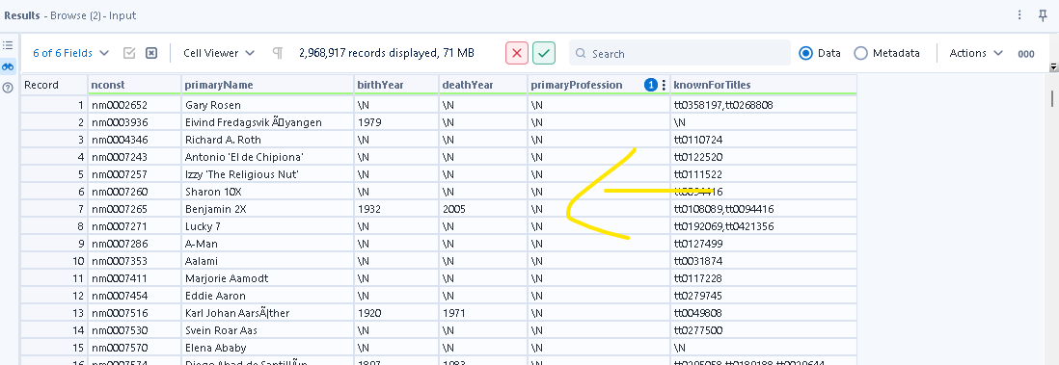

We Cannot drop the rows that have no primary name as they are associated with a nconst and therefore these \N values will be replaced with default values

Column Names | Replace ‘\N’ with | Reason
primaryName | Unknown | To maintain string format
birthYear | 0000 | To maintain numeric format
deathYear | 9999 | To indicate person is alive
primaryProfession | Unknown | To maintain string format
knownForTitles | Unknown | To maintain string format

Title.Akas

Total records – 54,124,127
Total Attributes – 8
Duplicates -

Basic view of data–

Attributes | Source Data type | Target Data Type
titleID | V_WString | V_String
Ordering | V_String | Integer
Title | V_String | V_String
region | V_String | V_String
language | V_String | V_String
types | V_String | Array
attributes | V_WString | Array
isOriginalTitle | V_WString | Integer

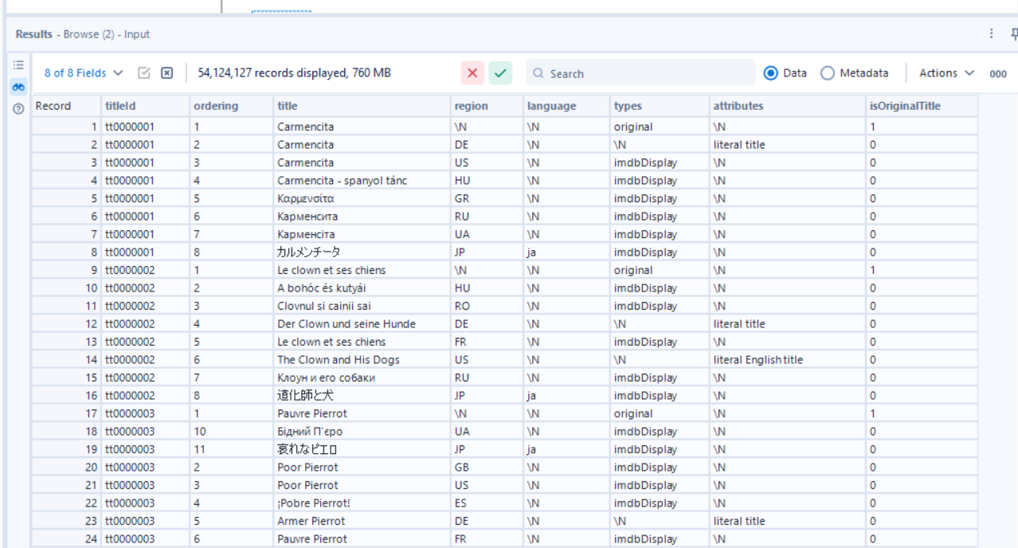

All the values in the data are distinct.
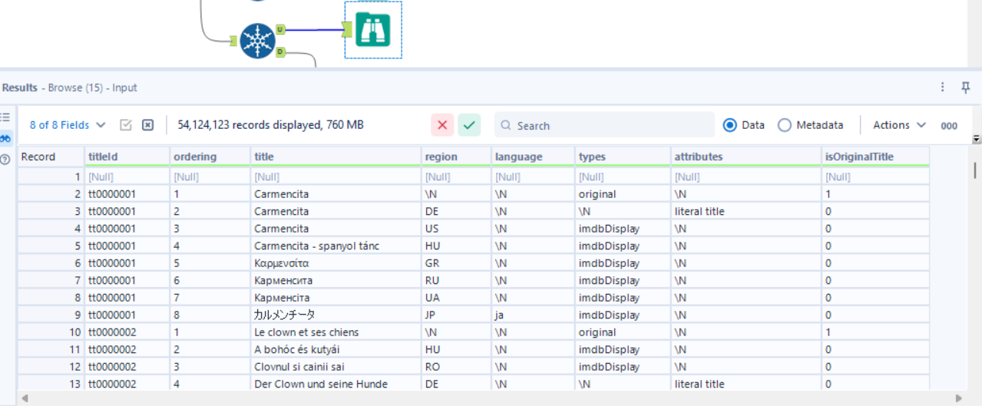

The corrected data types

All the nulls and the \N values will be replaced with appropriate default values.
Column Names | Replace ‘\N’ with | Reason
ordering | -1 | To maintain numeric format
title | Unknown | To maintain string format
Region | Unknown | To maintain string format
Language | Unknown | To maintain string format
types | Unknown | To maintain string format
Attributes | Unknown | To maintain string format
isOriginalTitle | -1 | To maintain numeric format

